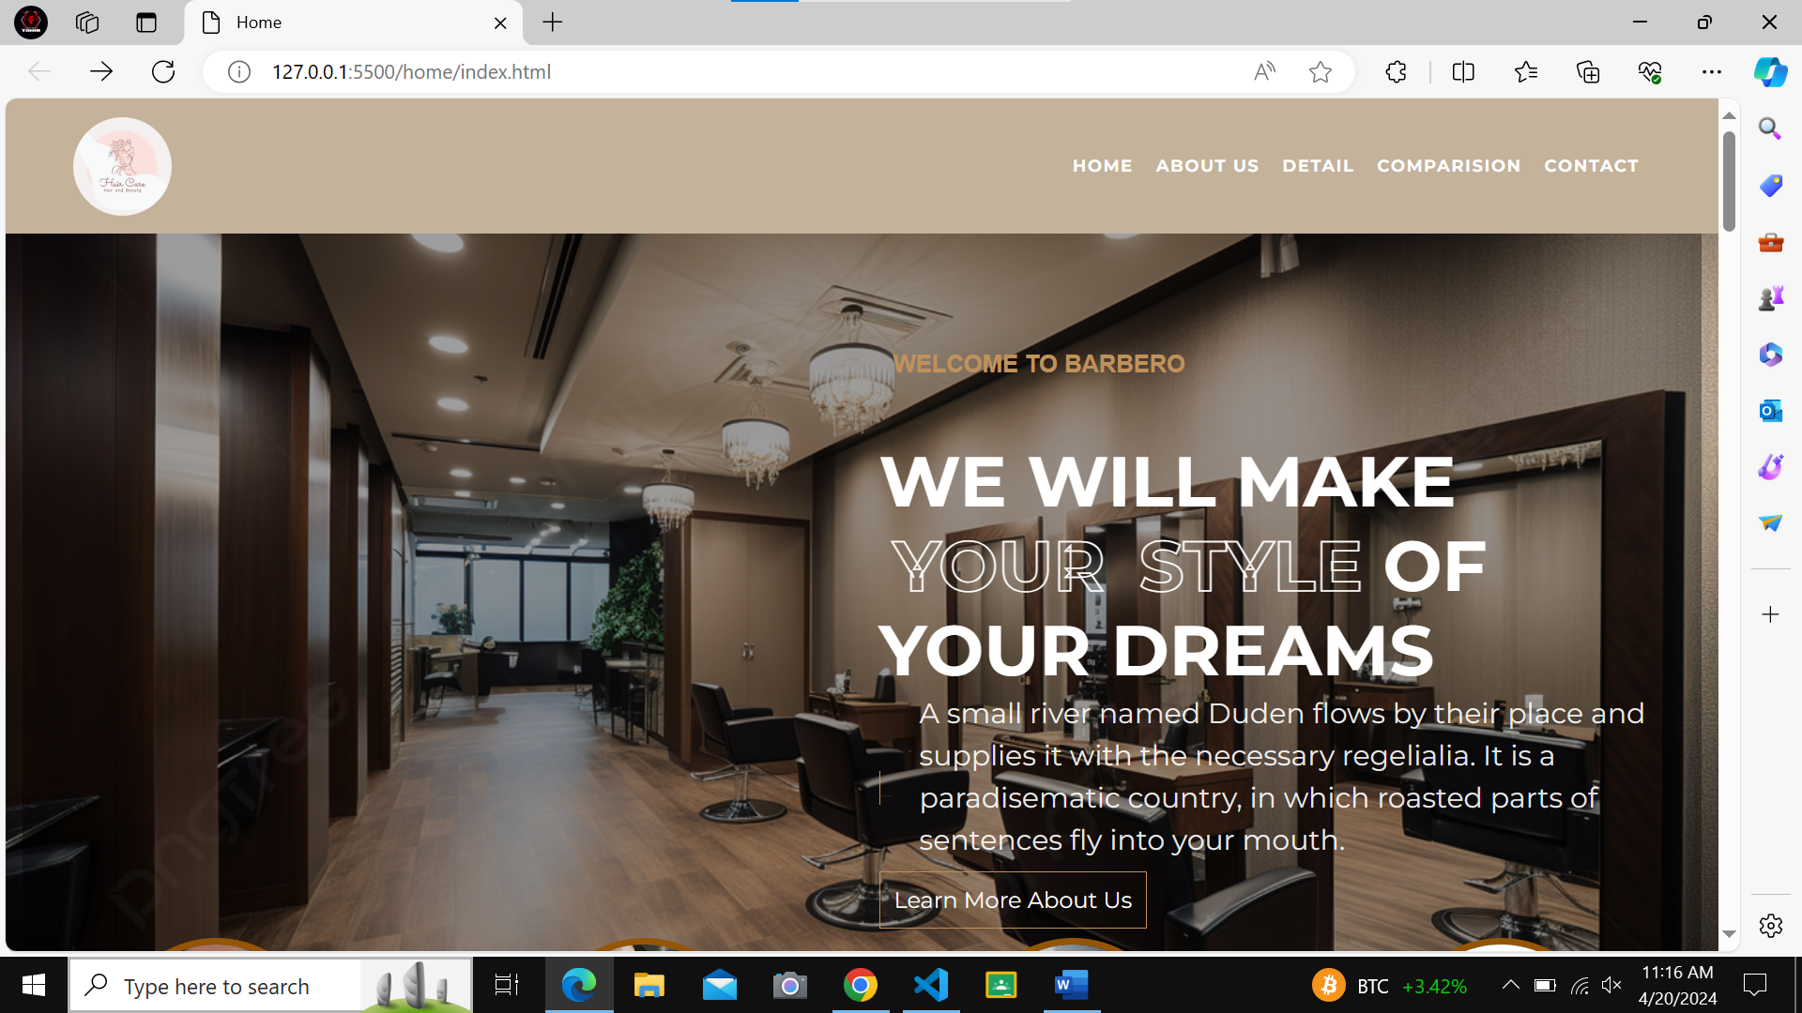

**HAIR CARE WEBSITE**

**OUR TEAM**

**M. TAHIR JAVED**

**M. MOOSA JAWED**

**M. KHIZER**

The thirst for lring, upgrading technical skills and applying the concepts in real life environment at a fast pace is what the industry demands from IT professionals today. However busy work schedules, far-flung locations, unavailability of convenient time-slots pose as major barriers when it comes to applying the concepts into realism. And hence the need to look out for alternative means of implementation in the form of laddered approach.

**INTRODUCTION**

The above truly pose as constraints especially for our students too! With their busy schedules, it is indeed difficult for our students to keep up with the genuine and constant need for integrated application which can be seen live especially so in the field of IT education where technology can change on the spur of a moment. Well, technology does come to our rescue at such times!!

Keeping the above in mind and in tune with our constant endeavour to use Technology in our training model, we at Aptech have thought of revolutionizing the way our students learn and implement the concepts using tools themselves by providing a live and synchronous eProject learning environment!

**So what is this eProject?**

eProject is a step-by-step learning environment that closely simulates the classroom and Lab based learning environment into actual implementation. It is a project implementation at your fingertips!! An electronic, live juncture on the machine that allows you to

* Practice step by step i.e. laddered approach.
* Build a larger more robust application.
* Usage of certain utilities in applications designed by user.
* Single program to unified code leading to a complete application.
* Learn implementation of concepts in a phased manner.
* Enhance skills and add value.
* Work on real life projects.
* Give a real life scenario and help to create applications more complicated and useful.
* Mentoring through email support.

The students at the centre are expected to complete this eProject and send complete project along with the documentation to eProjects Team.

Looking forward to a positive response from your end!!

**OBJECTIVES OF THE PROJECT**

The Objective of this program is to give a sample project to work on real life projects. These applications help you build a larger more robust application.

The objective is not to teach you HTML/JavaScript/Dreamweaver/HTML5 but to provide you with a real life scenario and help you create basic applications using the tools.

You can revise the chapters before you start with the project.

This project is meant for students who have completed the module of ***HTML5***. These programs should be done in the Lab sessions with assistance of the faculty if required.

It is very essential that a student has a clear understanding of the subject. Students should go through the project and solve the assignments as per requirements given.

Kindly get back to eProjects Team in case of any doubts regarding the application or its objectives.

Hair is probably one of the first things you notice about people when meeting them for the first time. This is especially true for women. Beautiful and shiny hair always leaves good impression, which is why proper hair care is important. Also, good care of your hair plays an important part in having healthy hair and helps avoid extensive damage that can lead to **hair loss**. Regular washing with celebrity advertised shampoos and conditioners is not enough. To have a healthy, strong and shiny hair, you need to know how to care for it daily.

**PROBLEM STATEMENT**

Since the field is really vast, a need is felt that there should be a single platform which will give the complete information of haircare

**REQUIRMENT SPECIFICATION:**

The Web site is to be created based on the following requirements.

1. Home page with suitable logo and images, making use of sections.
2. Categorized menu which will include various categories as type of treatments available for various different hair problems like
   1. Hair loss
   2. Graying
   3. Growth related
   4. Premature baldness etc
3. The site should also include the various easy home remedies that can be helpful in dealing with various hair related issues
4. There should be a section which will provide the details of hair care equipments like
   1. Dryers
   2. Straightners
   3. Spray bottles
   4. Steamers
   5. Massagers
   6. Spa caps
5. There should also be a section for hair care products as
   1. Hair cream
   2. Shampoo
   3. Conditioners
   4. Masks
   5. Serums
   6. Hairsprays
   7. Various hair oils
6. Along with the various equipments, there should also be user manual/guidelines for ease of its use and maintenance.
7. The site should also include the details as of which companies provide which equipments
8. Comparison among the same equipment of different companies should be possible based on availability, cost major features
9. Gallery section should include most common instruments along with their necessary details.
10. There should be a section which will enable user to know latest developments in the field
11. Contact us page: contact us details with location should be displayed using GeoLocation API (eg. GoogleMaps).
12. Navigation needs to be smoother.
13. The look and feel of the project must be made user friendly and uniformity in the color combination must be maintained.

**HARDWARE AND SOFTWARE REQUIRMENTS**

**Hardware**

* A minimum computer system that will help you access all the tools in the courses is a Pentium 166 or better
* 64 Megabytes of RAM or better

**Software *[Either or Combination as per Course/Sem]***

* Notepad/HTML editor/CoffeeCup
* Angular / Angular JS / React / BootStrap
* Dreamweaver / Figma
* MS IE / Chrome / FireFox / Netscape /MS Edge

**WEBSITE IMAGES**

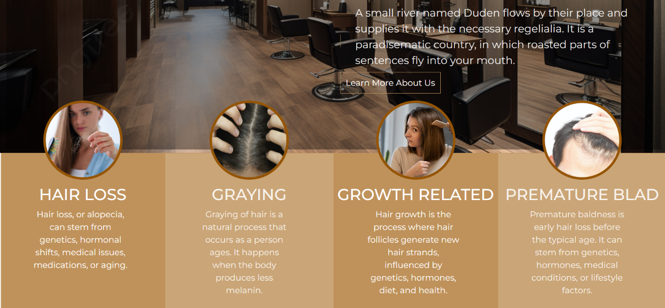

**ABOUT US**

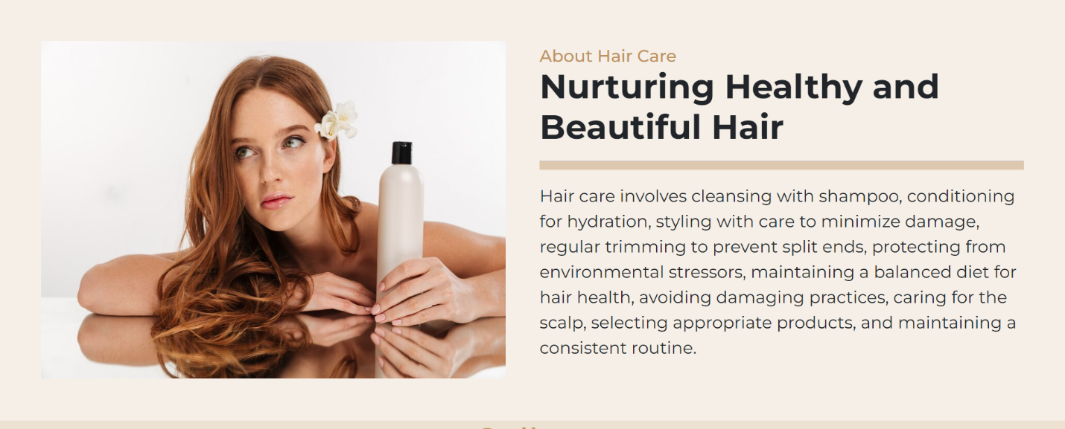

**GALLERY**

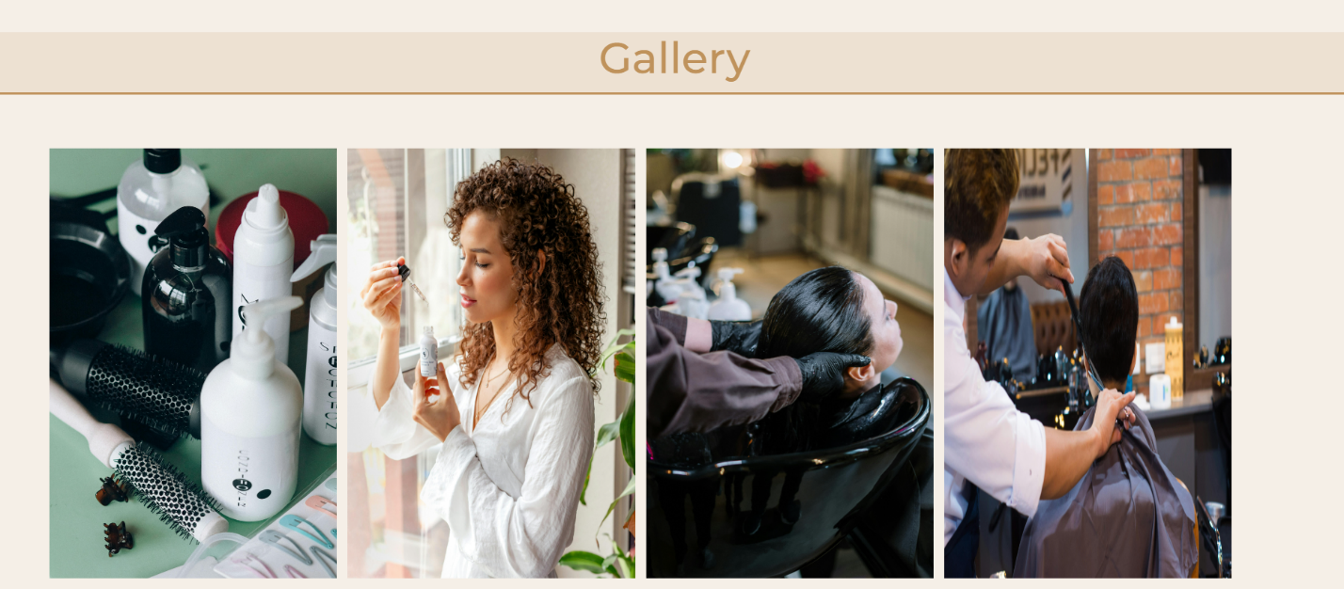

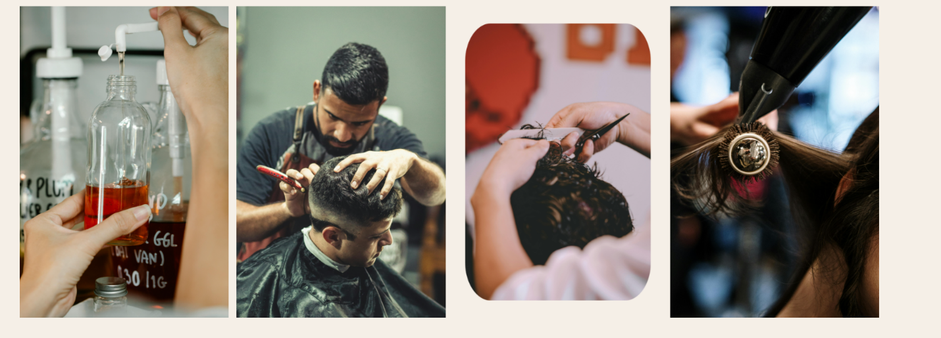

**HAIR EQUIPMENTS**

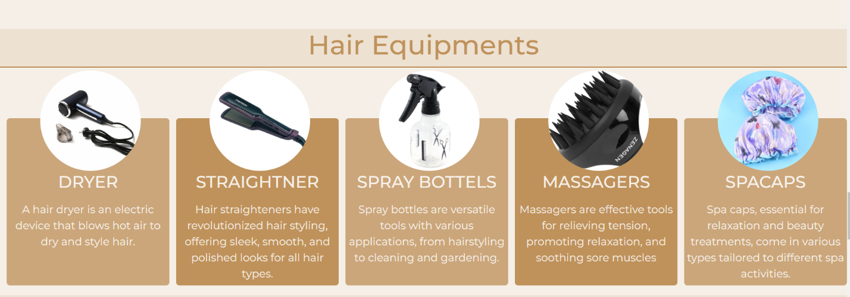

**HAIR PRODUCT**

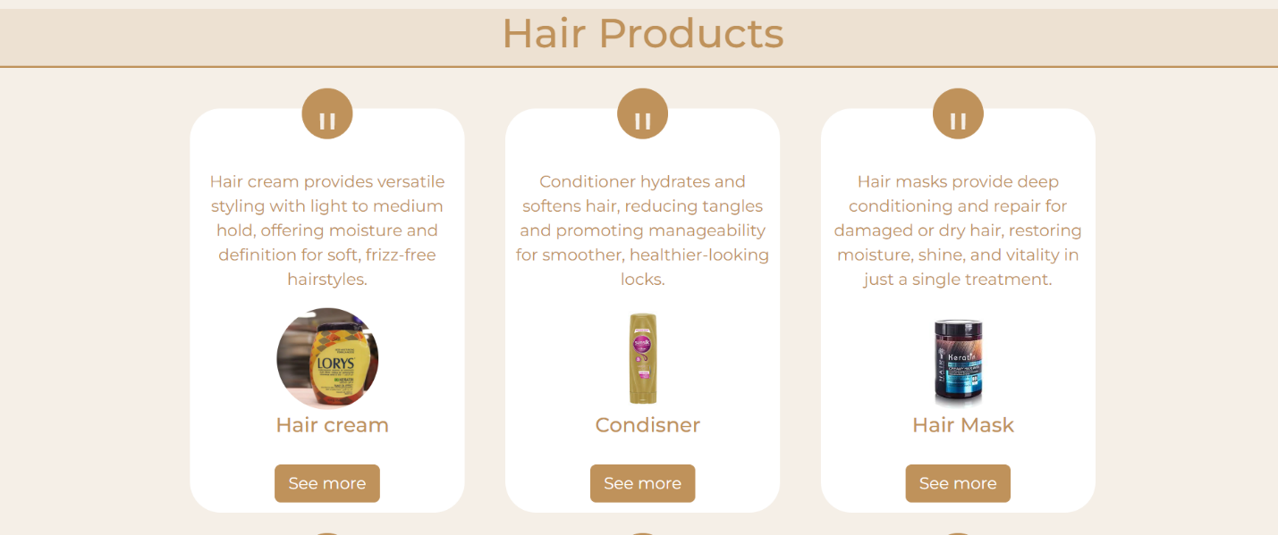

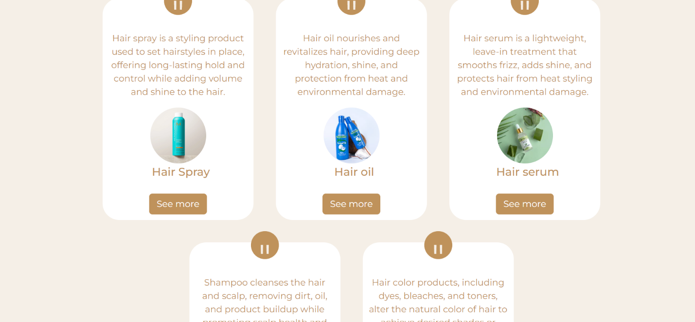

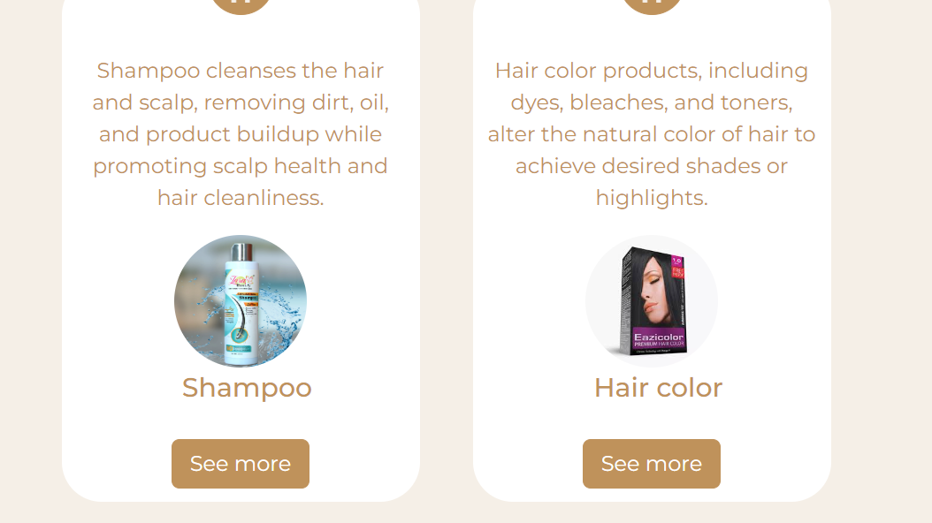

**Detail page**

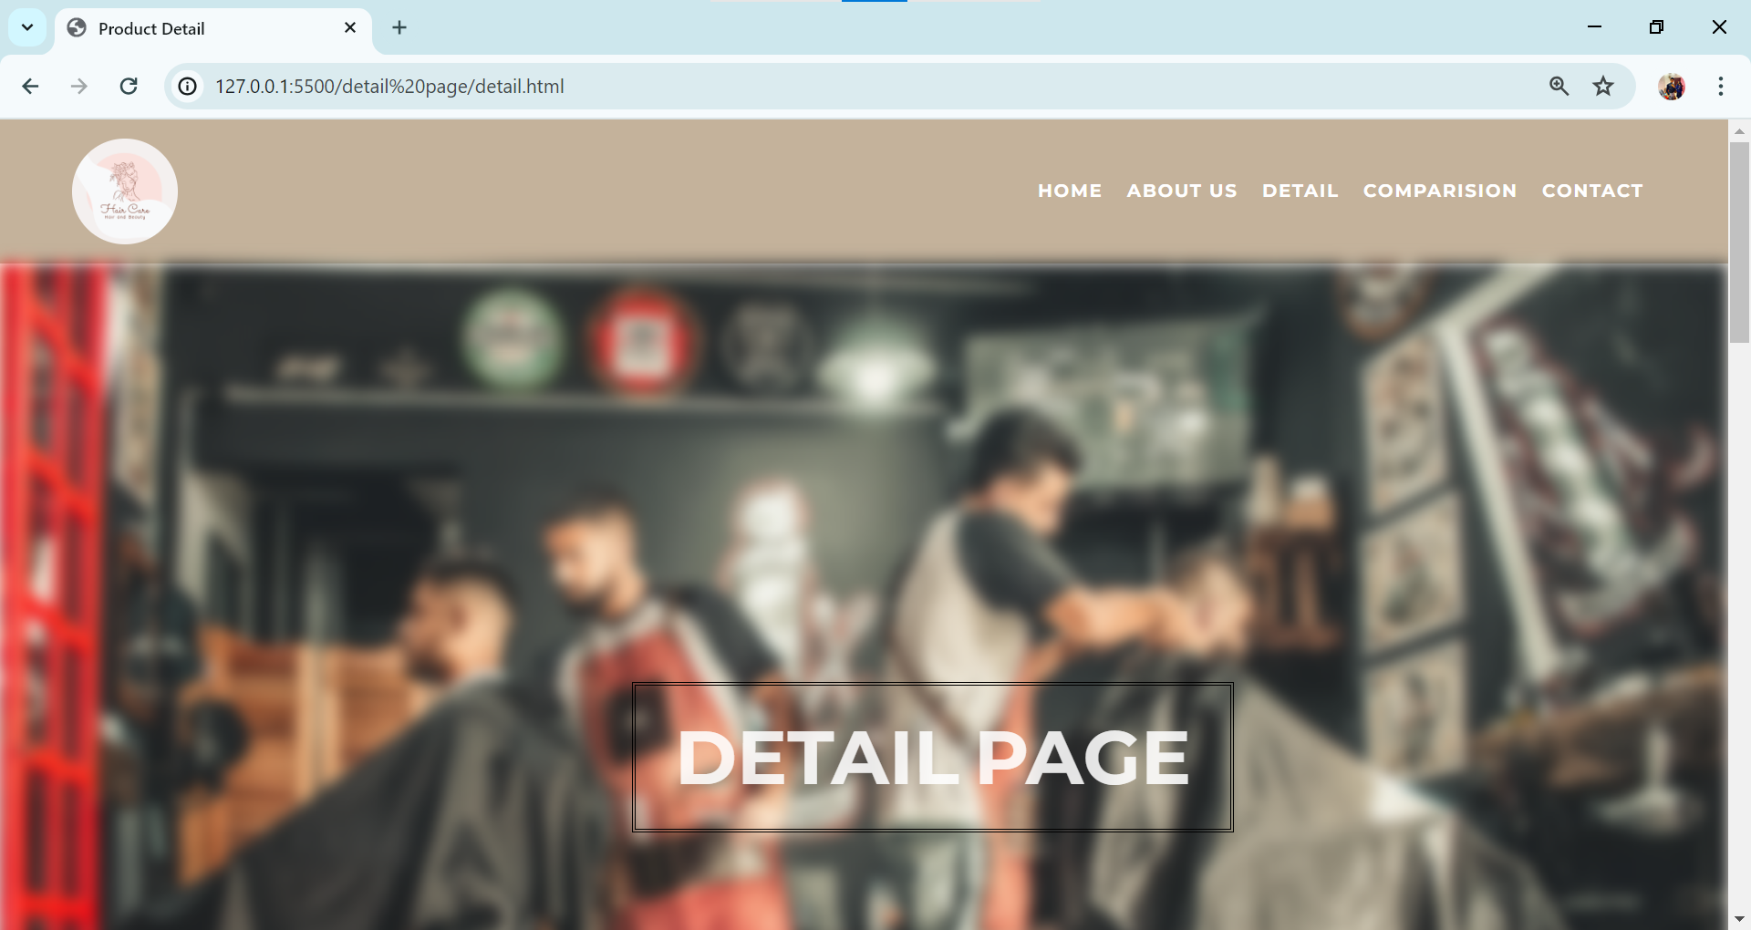

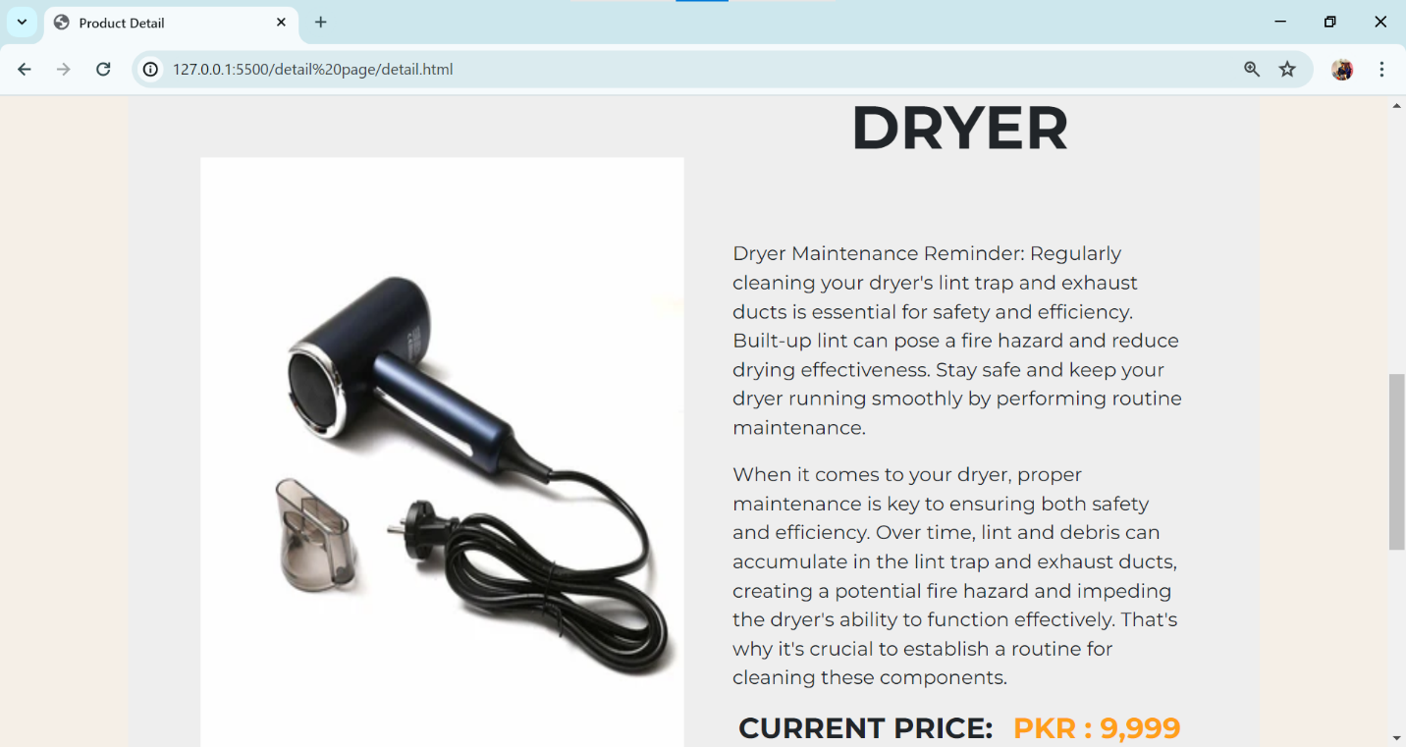

**CONTACT US**

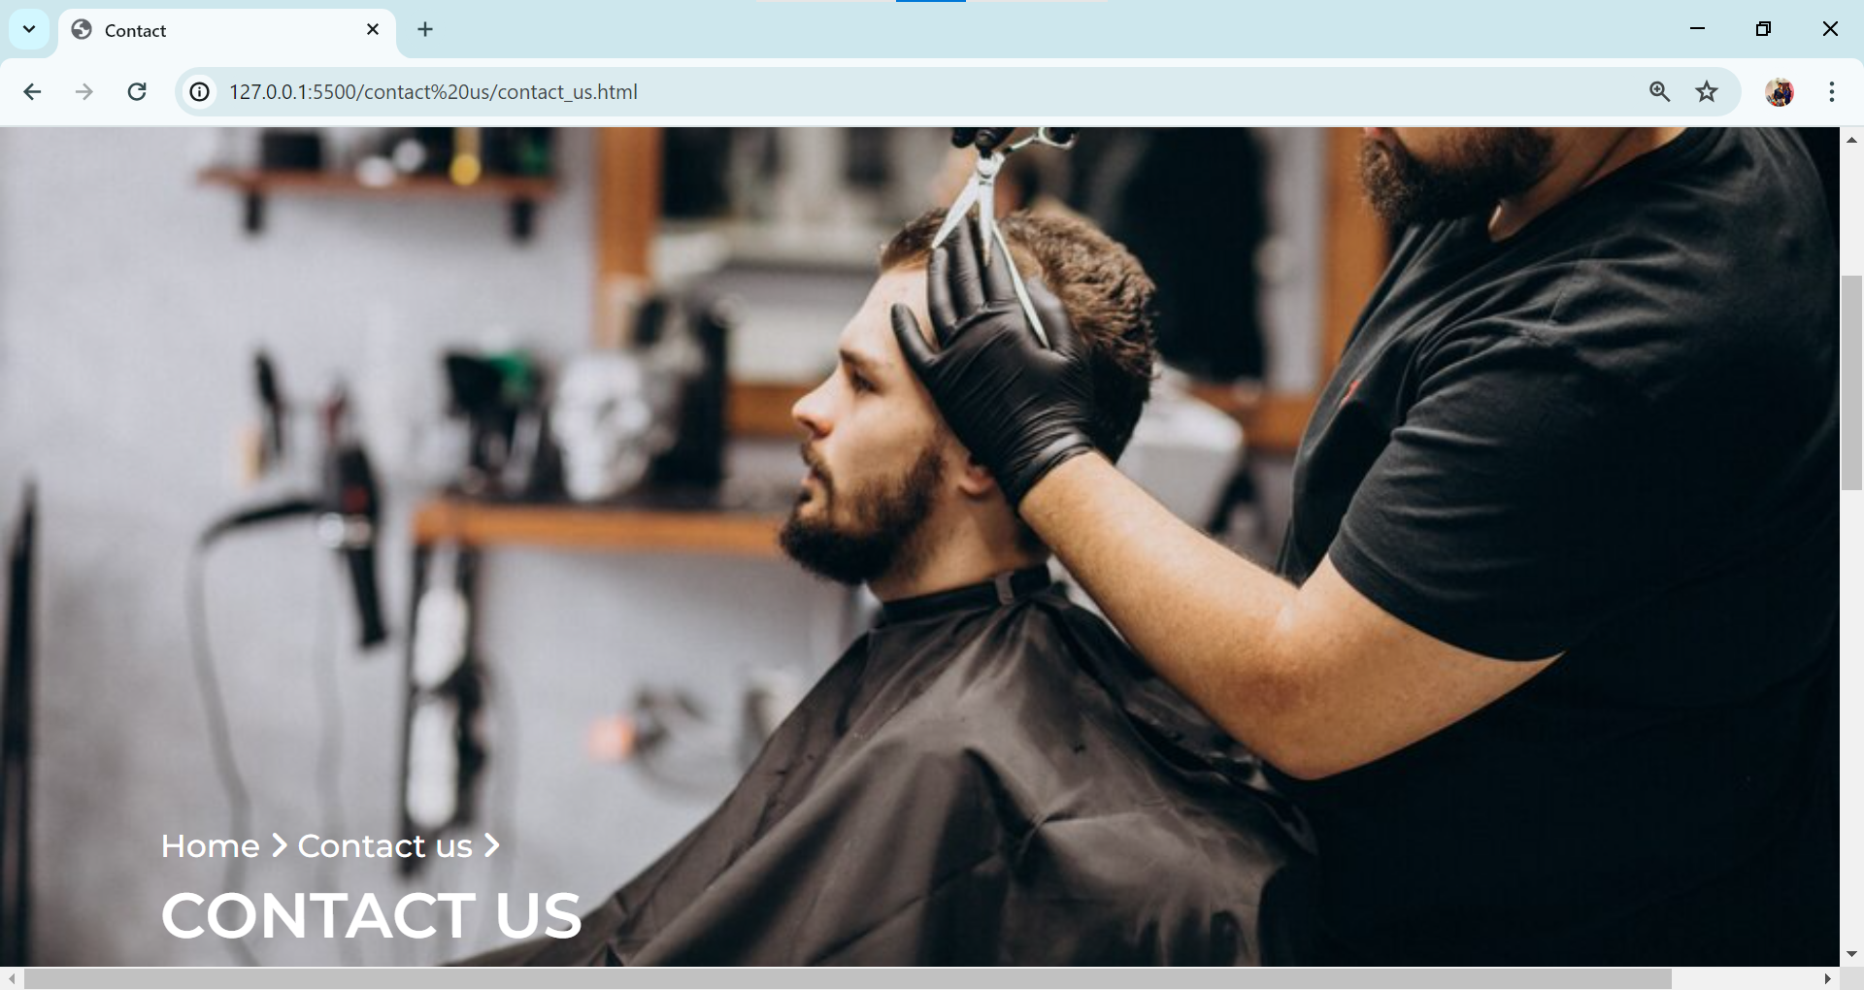

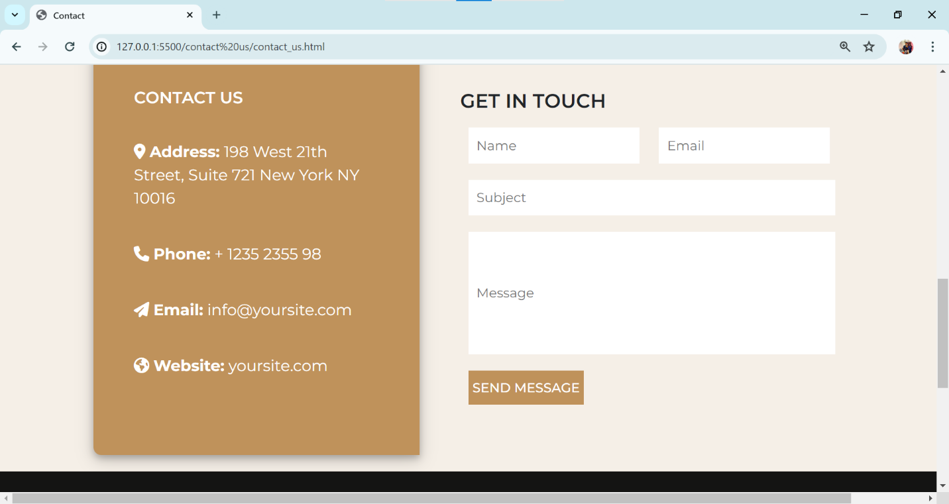

**COMPARE**

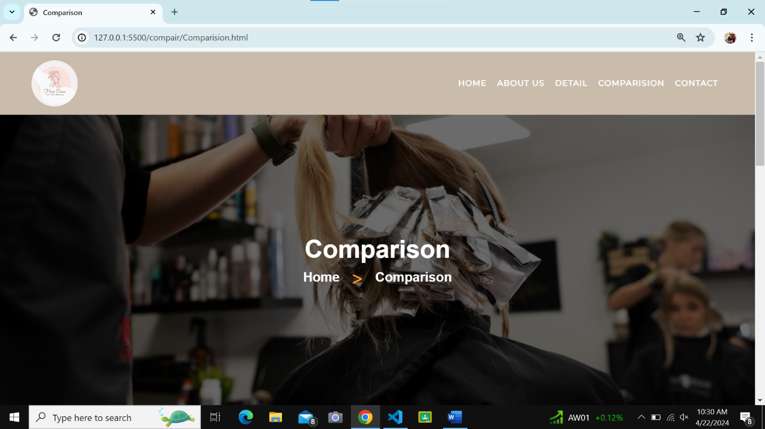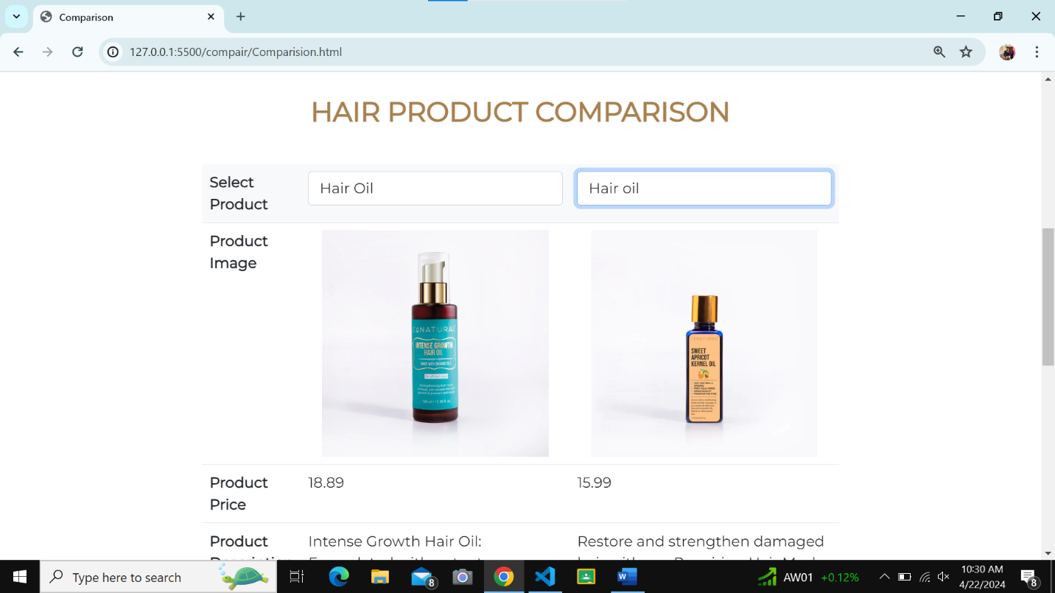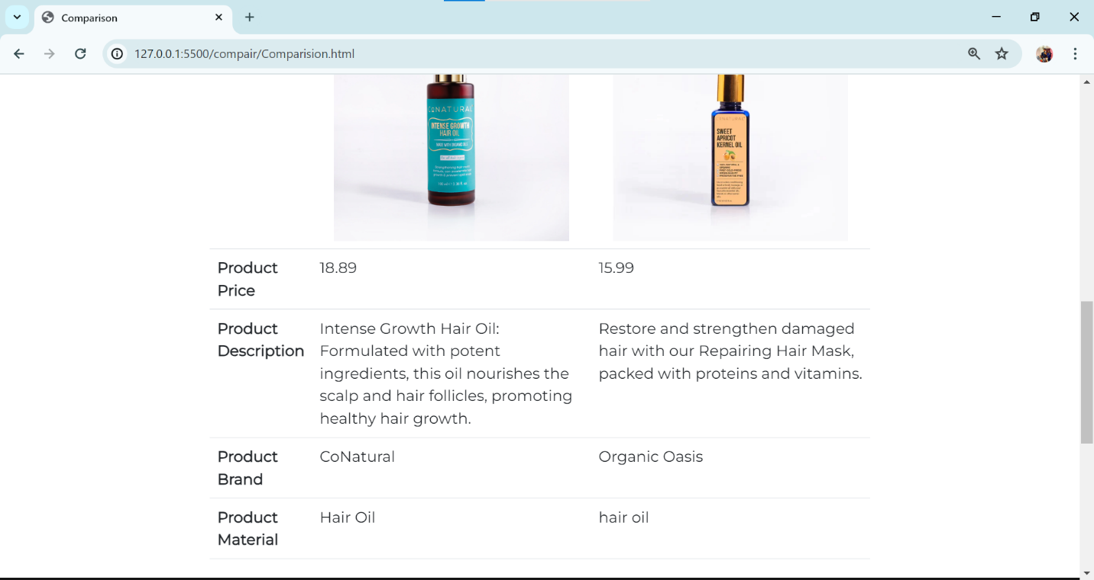

**ABOUT US**

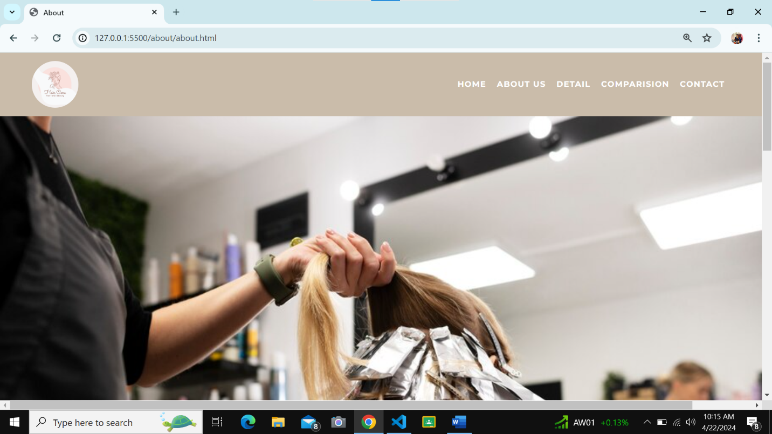

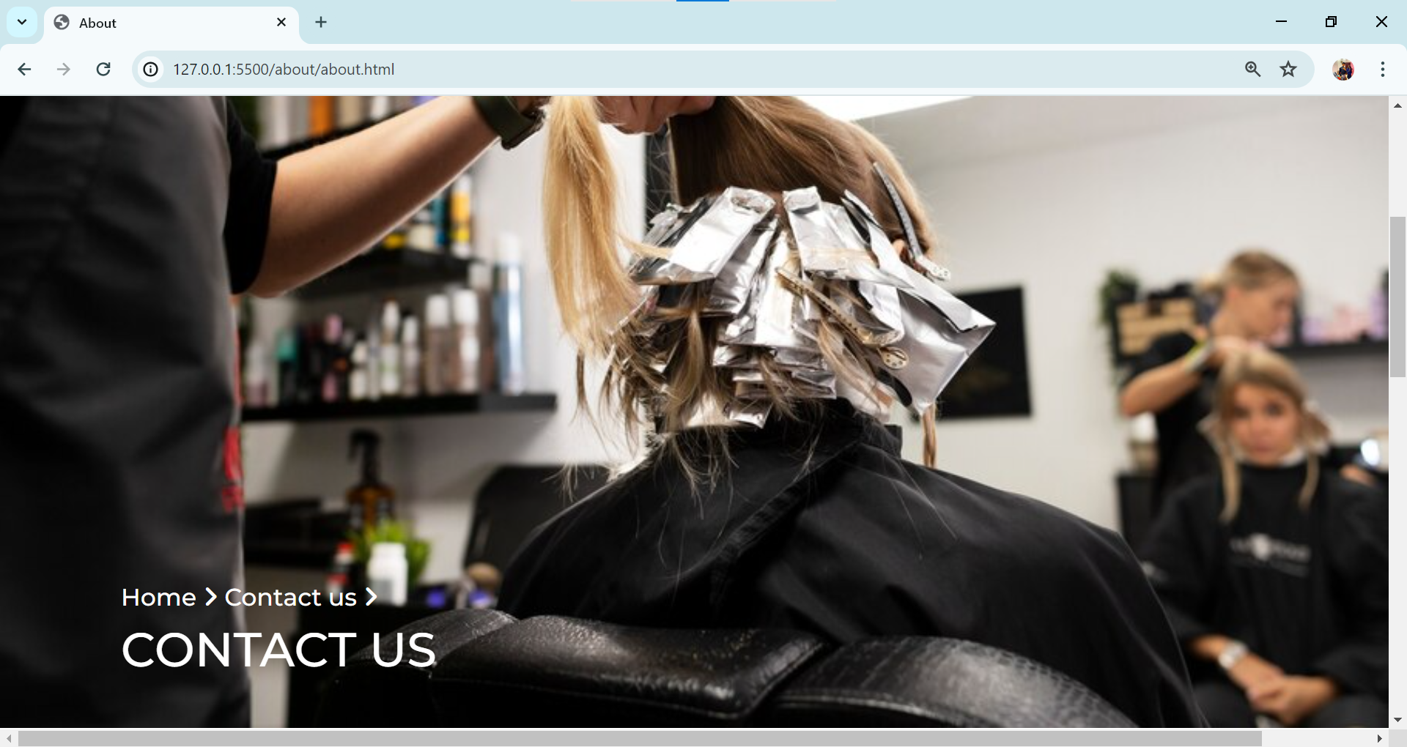

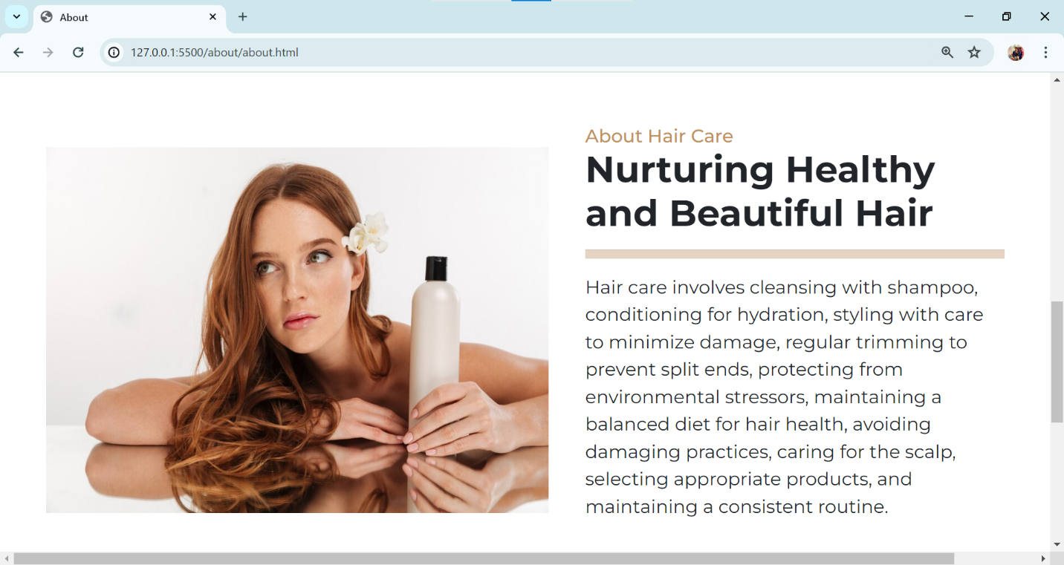

**FOOTER**

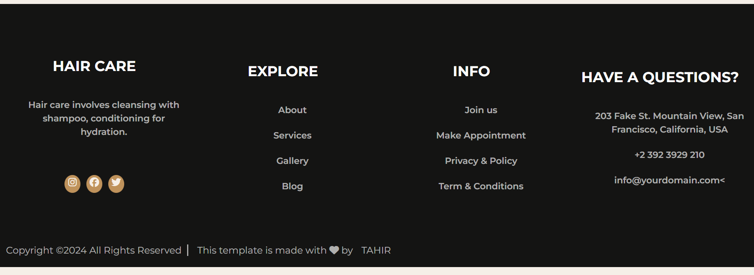

**SOURCE**

**NAVBAR**

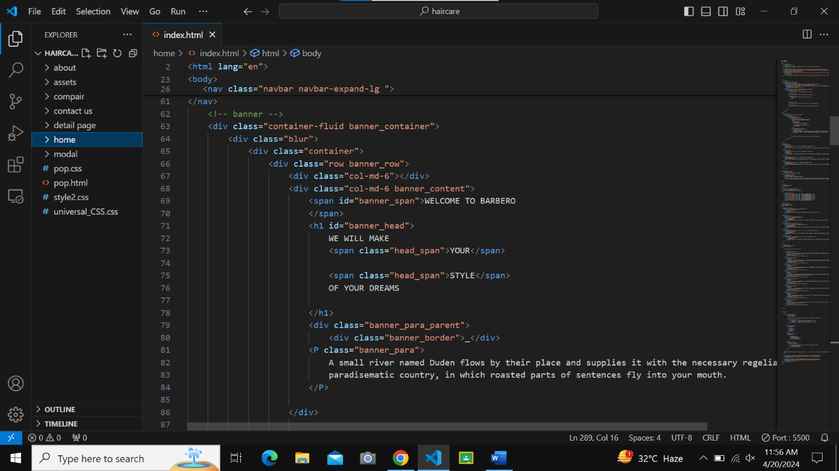

**CARDS**

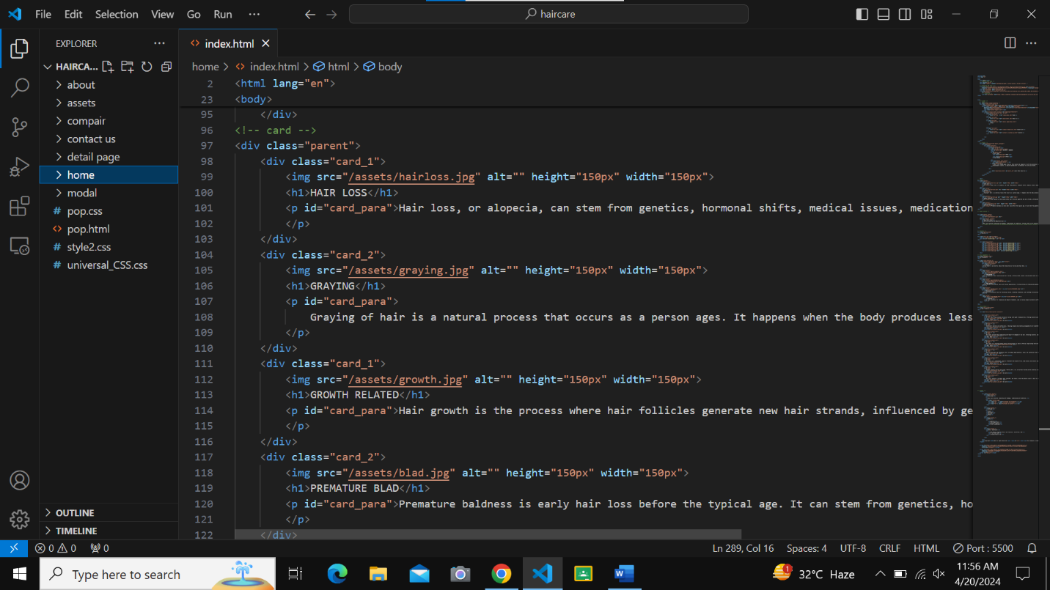

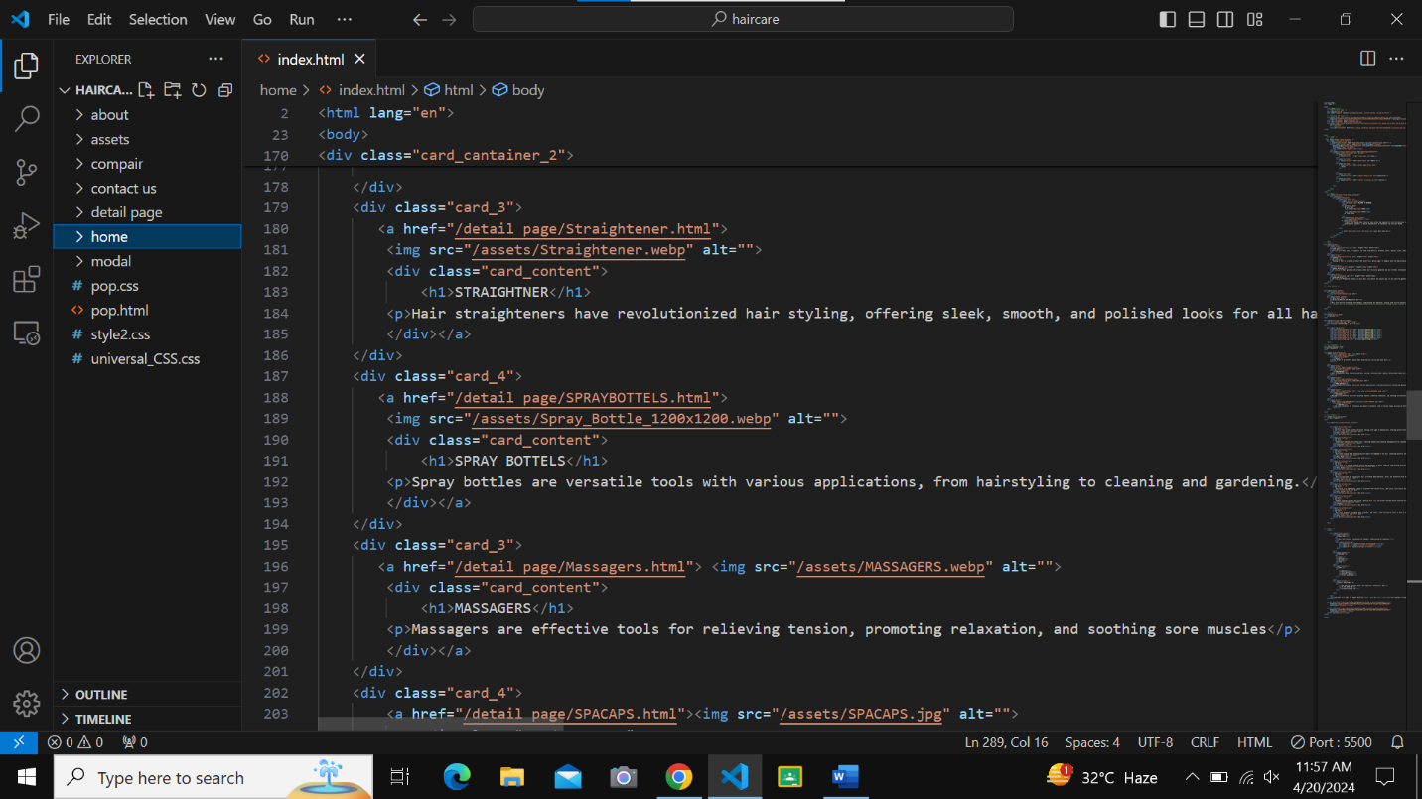

**GALLERY**

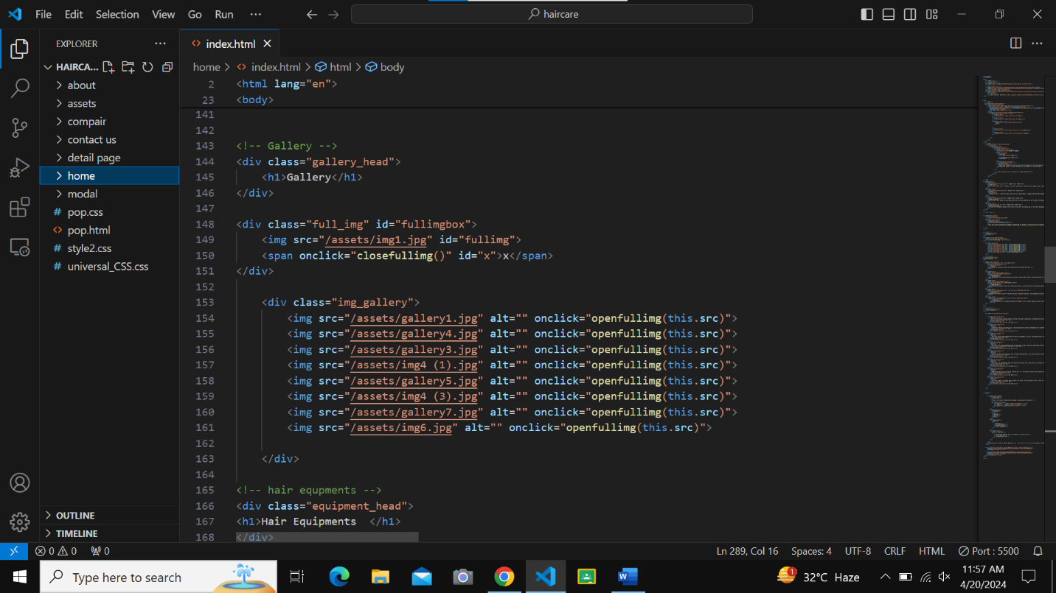

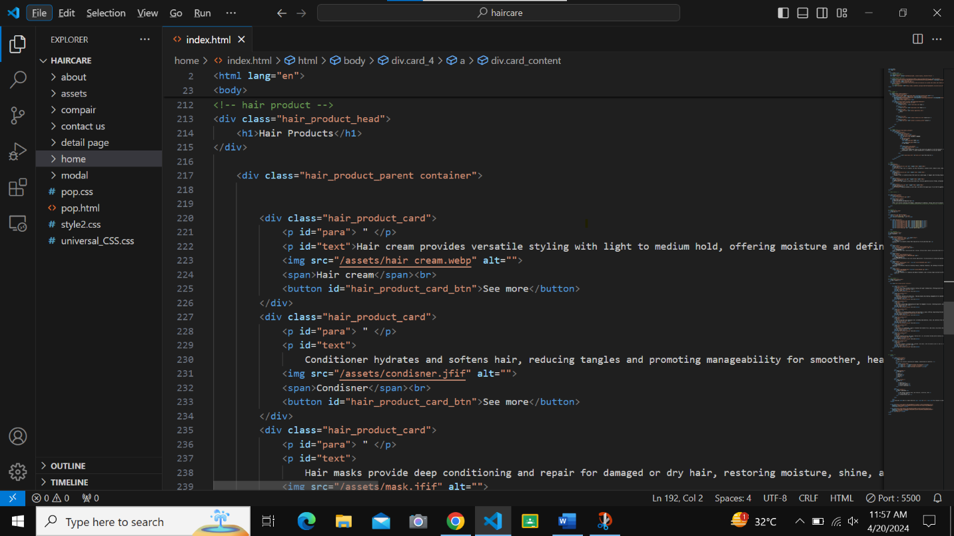

**LOCATION**

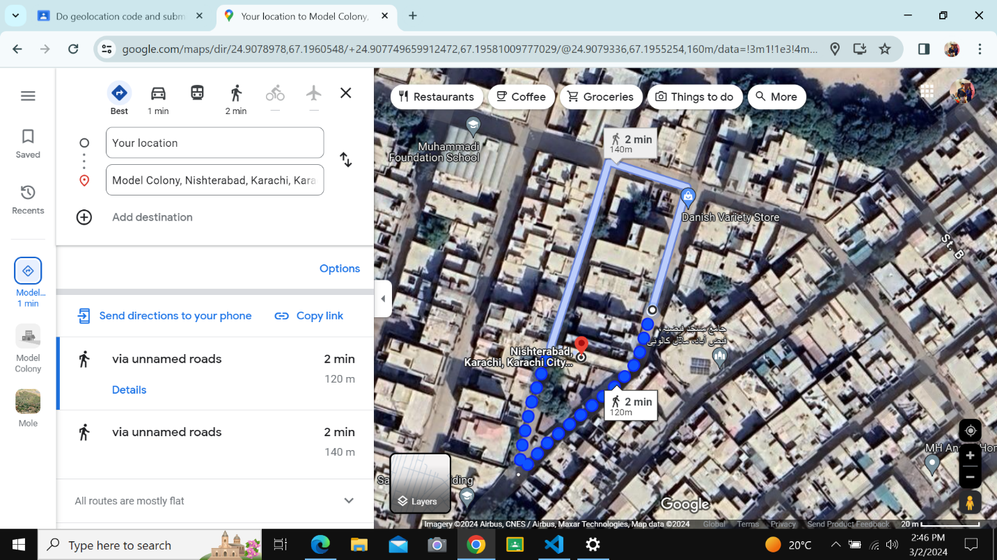

**HAIR PROCUCT**





**ABOUT US**

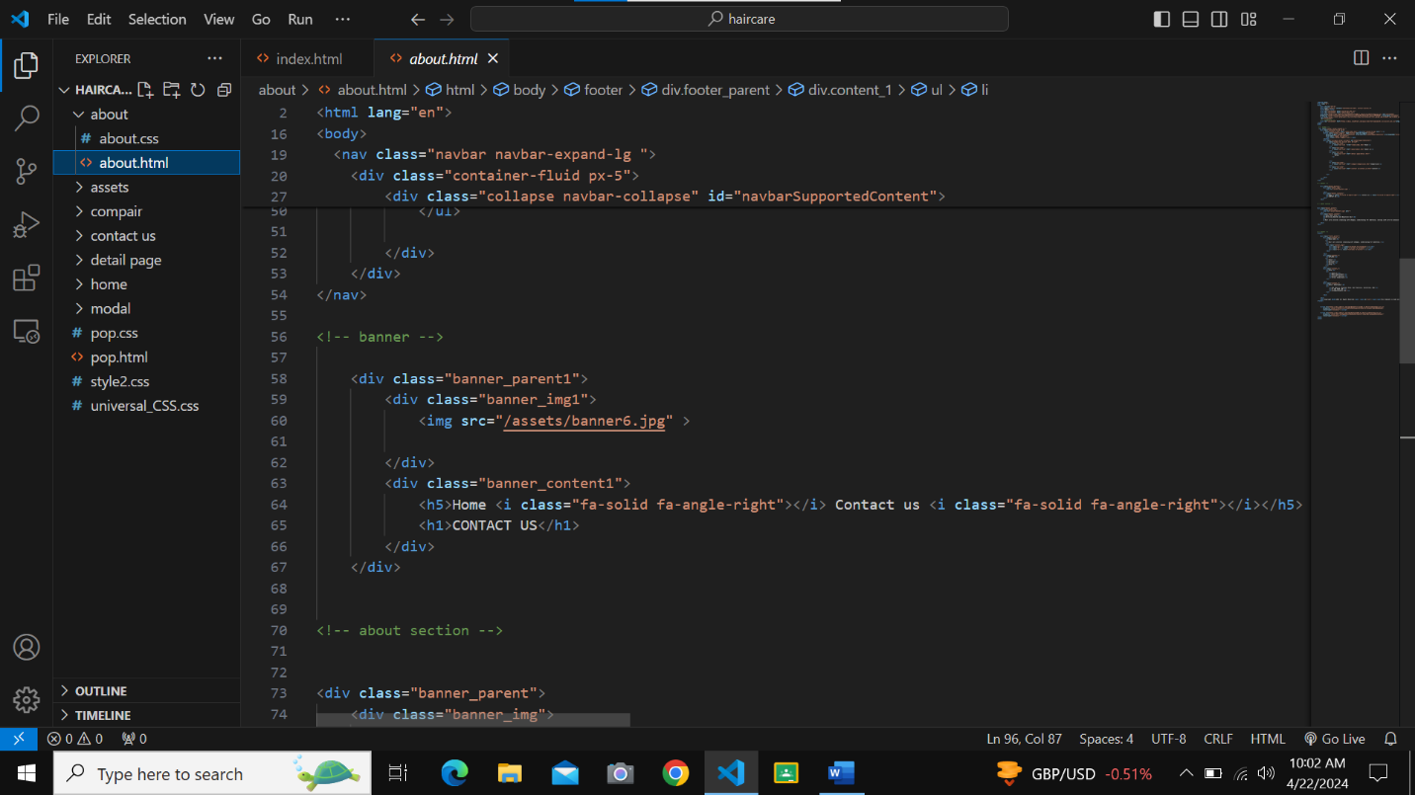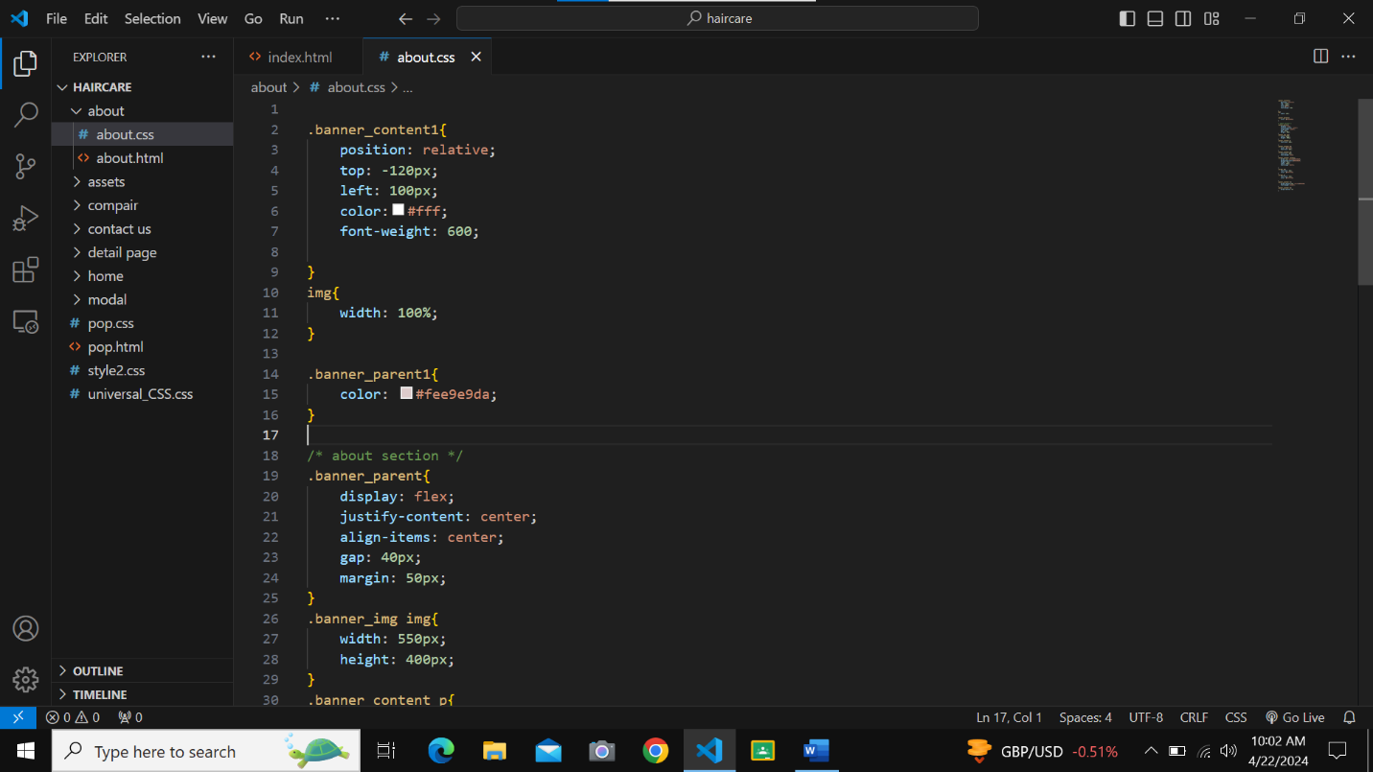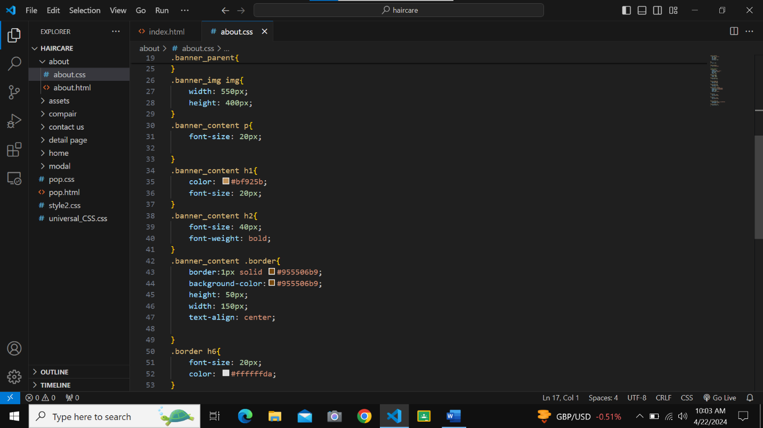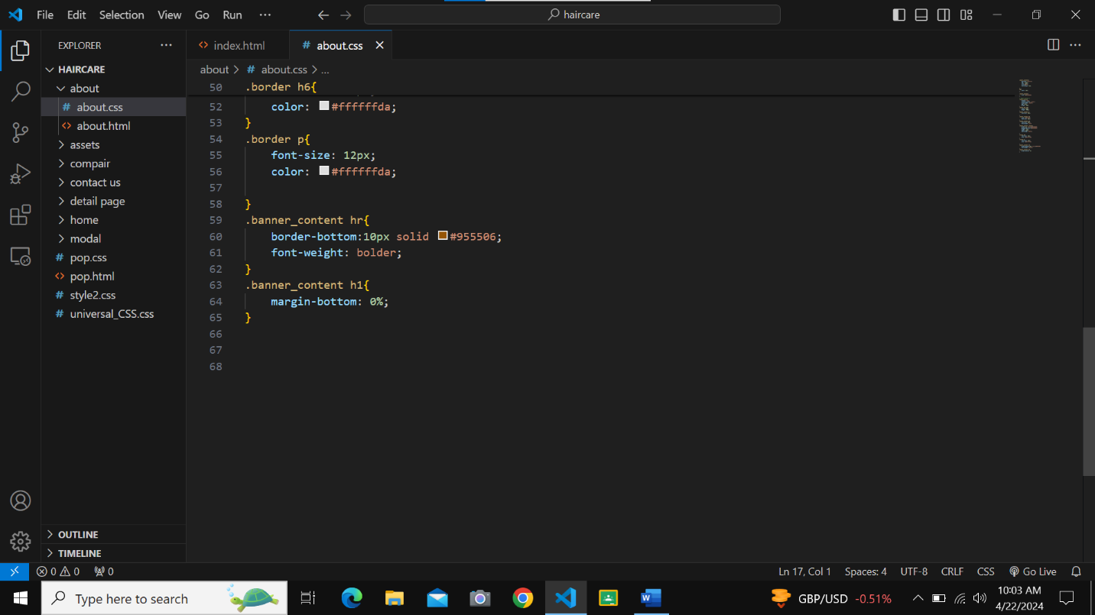

**COMPARISION**

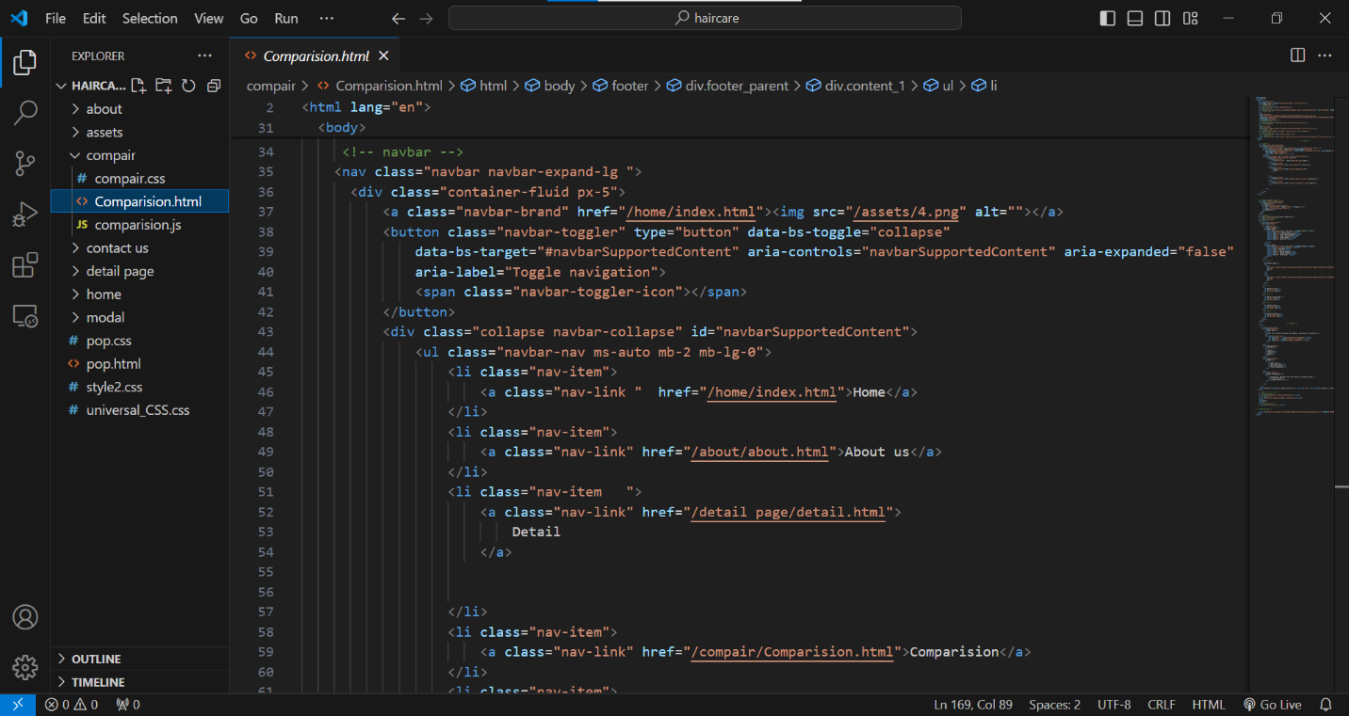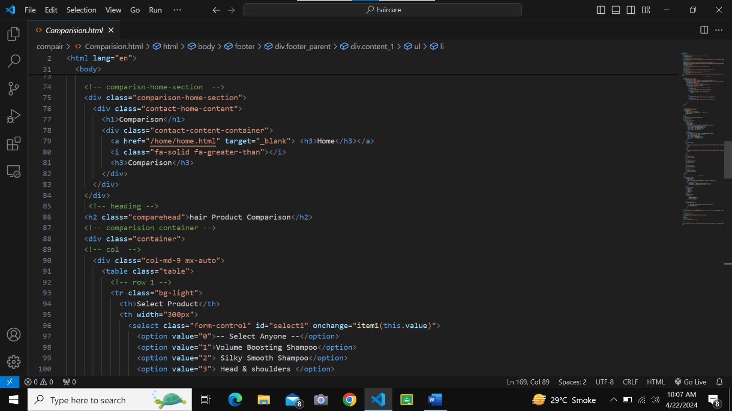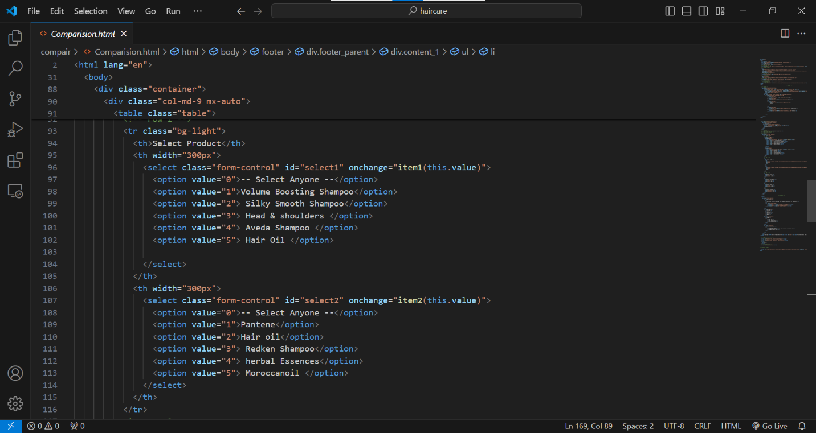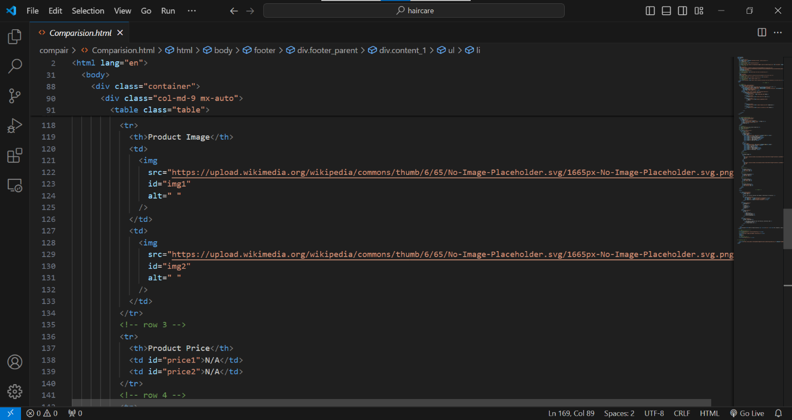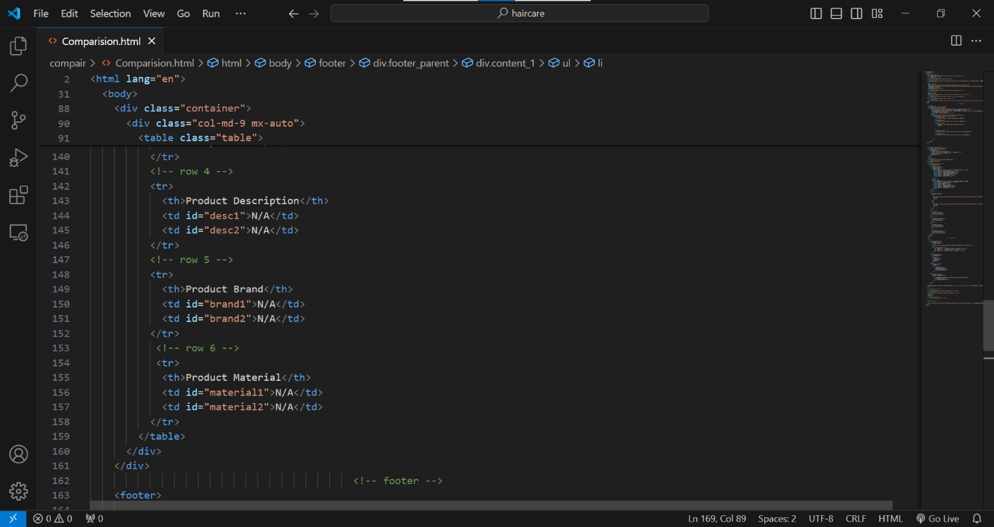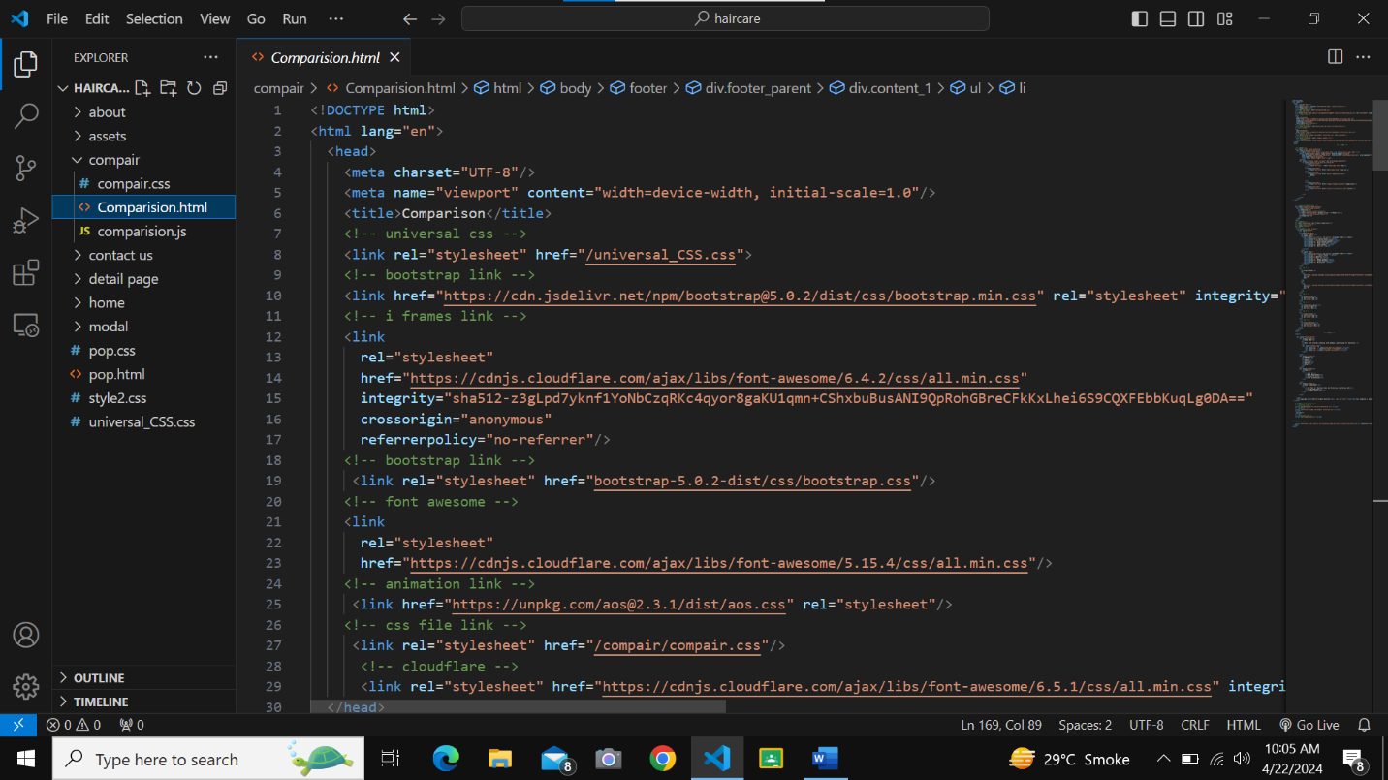

**DETAIL PAGE**

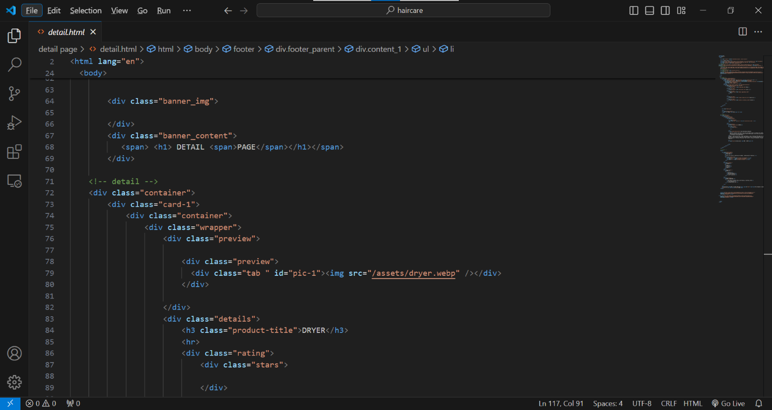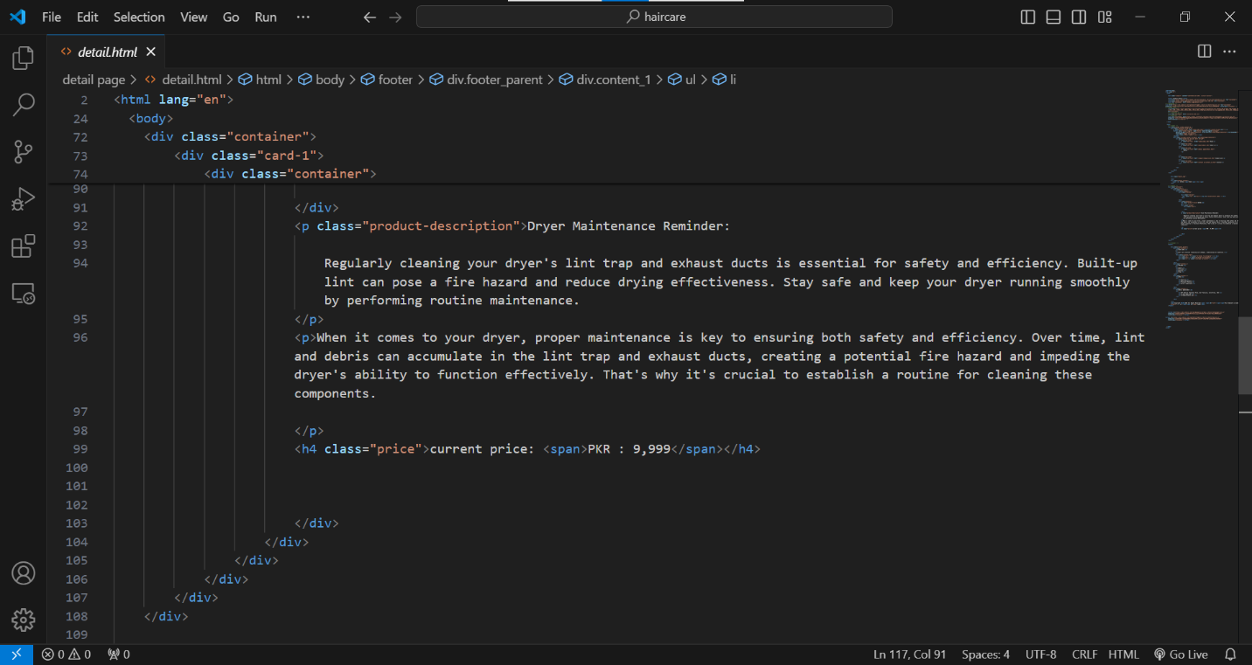

**CONTACT US**

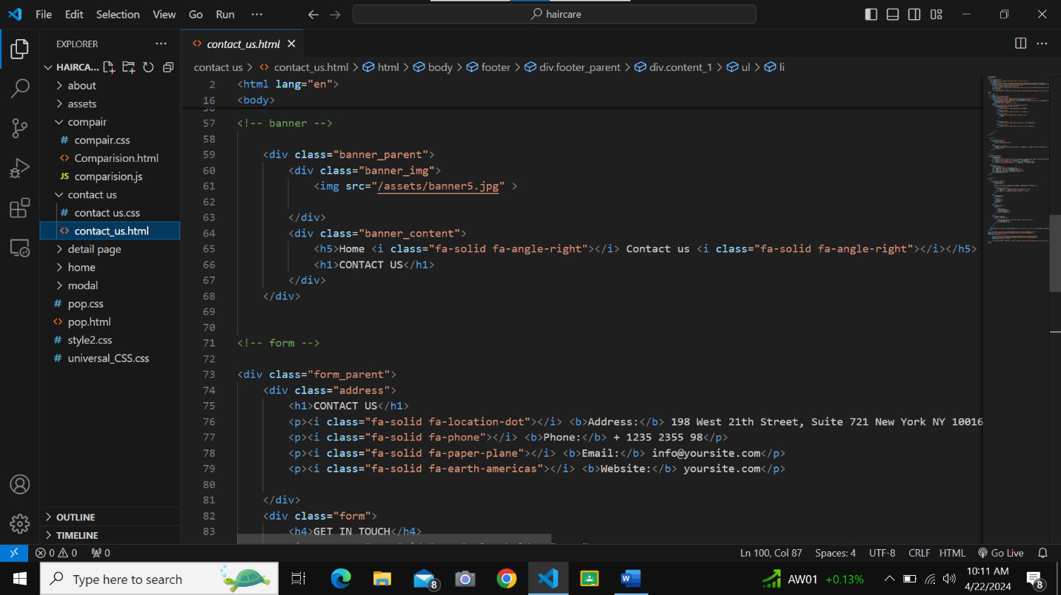

**LINKS**

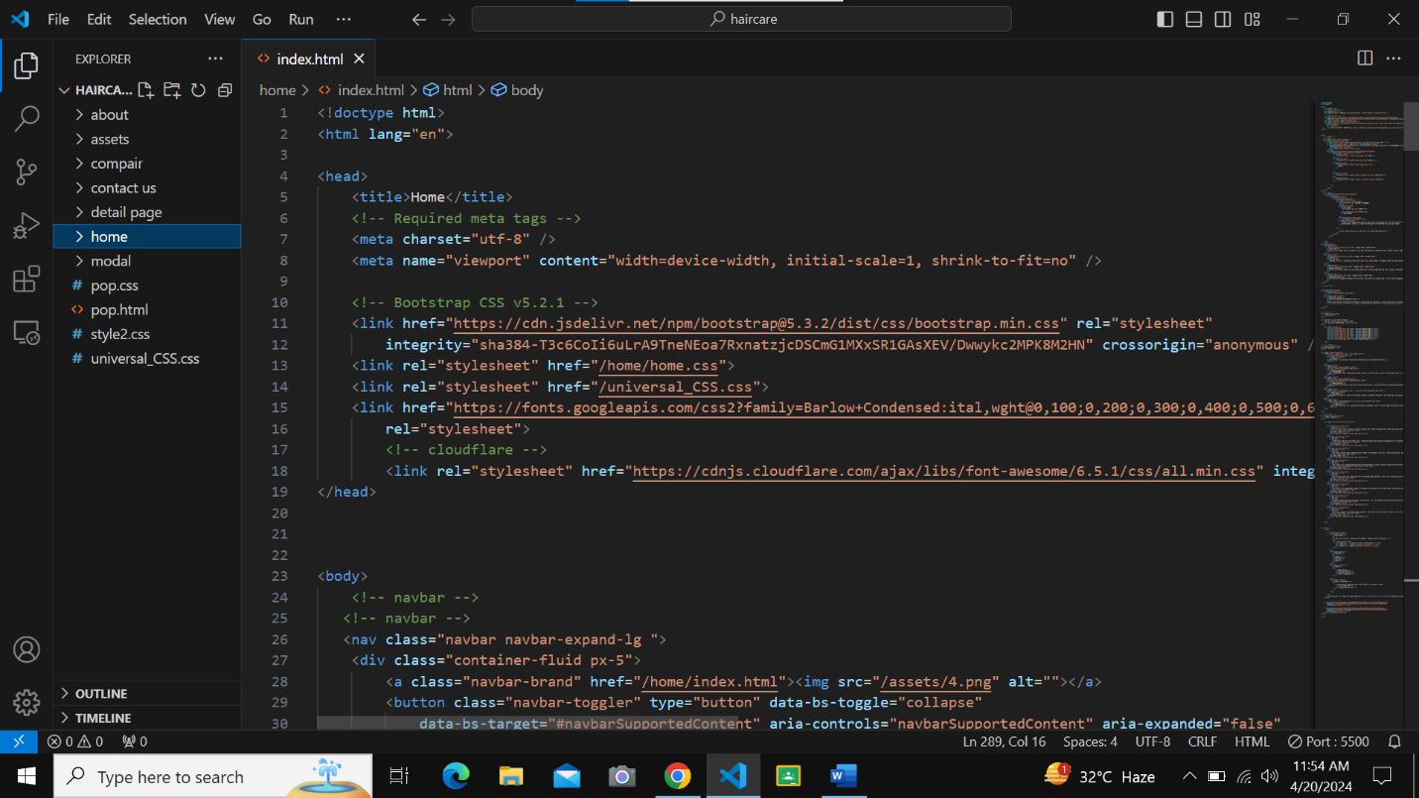

**JAVASCRIPT LINKS**

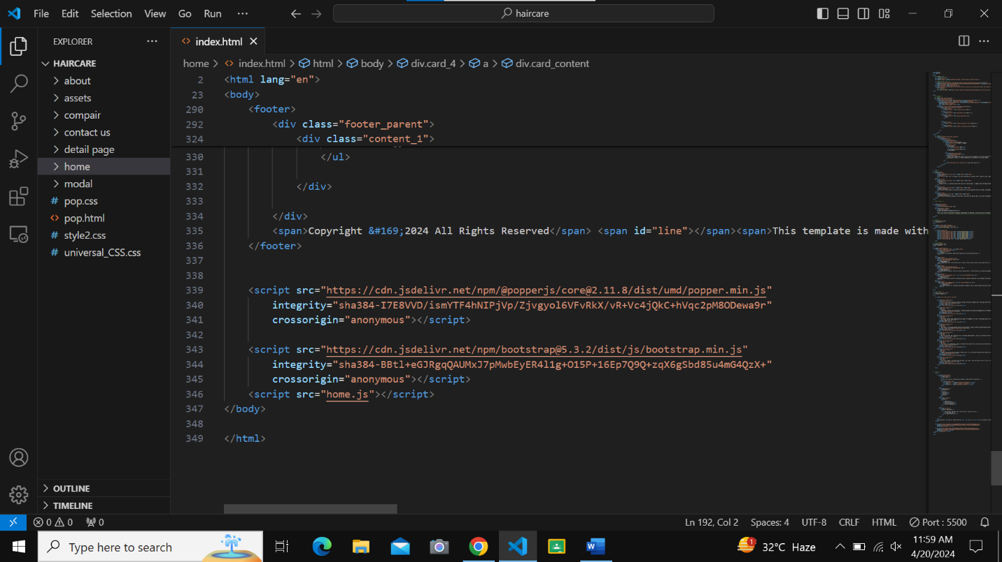

**FOOTER**

